Henry Lankin

Gui Larangeira

January 26, 2017

STAT 6305

Dr. Zhou

HW 2: 14.5a,b,c, 14.6a,b

14.5

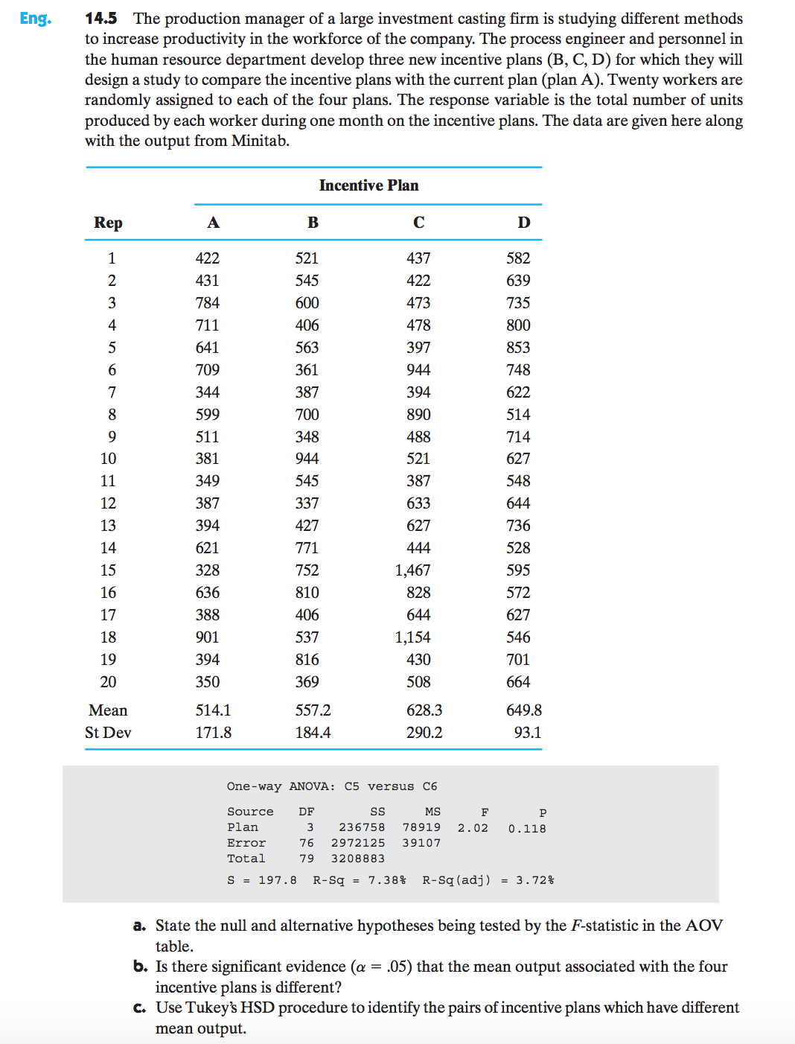

1. State the null and alternative hypothesis being tested by the $F$-statistics in the AOV table.

Hypotheses being tested:

$$H_{0}:μ_{A}=μ_{B}=μ_{C}=μ_{D}$$

$$H_{a}:At least one of the population mean units produced$$

$under a plan differs from the others$

1. Is there significant evidence ($α=0.05$) that the mean output associated with the four incentive plans is different?

| **Source** | **DF** | **Sum of Squares** | **Mean Square** | **F Value** | **Pr > F** |
| --- | --- | --- | --- | --- | --- |
| **Model** | 3 | 236991.238 | 78997.079 | 2.02 | 0.1181 |
| **Error** | 76 | 2971586.650 | 39099.824 |  |  |
| **Corrected Total** | 79 | 3208577.888 |  |  |  |

No, there is not significant evidence that at least one is different from the others since the $p$-value $=0.118>0.05$.

1. Use Fisher’s LSD procedure to identify the pairs of incentive plans which have different mean output.

|  |  |
| --- | --- |
| **Alpha** | 0.05 |
| **Error Degrees of Freedom** | 76 |
| **Error Mean Square** | 39099.82 |
| **Critical Value of t** | 1.99167 |
| **Least Significant Difference** | 124.54 |

| **Means with the same letter are not significantly different.** | | | | |
| --- | --- | --- | --- | --- |
| **t Grouping** | | **Mean** | **N** | **method** |
|  | A | 649.75 | 20 | D |
|  | A |  |  |  |
| B | A | 628.30 | 20 | C |
| B | A |  |  |  |
| B | A | 557.25 | 20 | B |
| B |  |  |  |  |
| B |  | 514.05 | 20 | A |

Fisher’s LSD procedure suggests that there is a significant difference between treatment A and treatment D, but, as seen in part (b), we would not continue to this step because there is not significant evidence that any of the treatment means differ from the others.

14.6

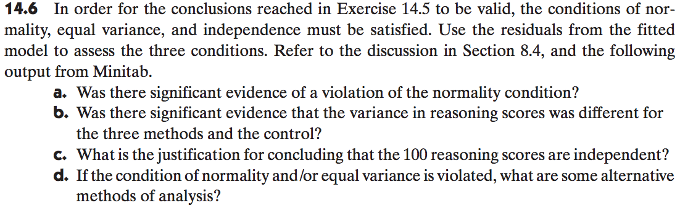

1. Was there significant evidence of a violation of the normality condition?

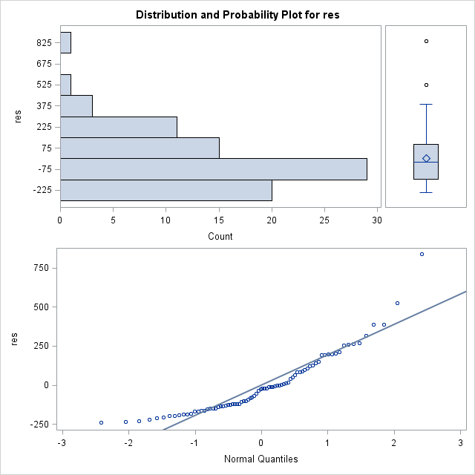

|  |  |  |  |  |
| --- | --- | --- | --- | --- |
| **Shapiro-Wilk** | **W:** | 0.883261 | **Pr < W:** | <0.0001 |

We see from the normal QQ-plot that the residual values deviate significantly from the regression line and the box plots do not look to match a normal curve. Further, the Shapiro-Wilk test gives a $p$-value less than 0.0001, signifying that we would reject the null hypothesis of normality. Thus, there is significant evidence that the normality condition is violated.

1. Was there significant evidence that the variance in reasoning scores was different for the three methods and the control?

| **Levene's Test for Homogeneity of Y Variance ANOVA of Squared Deviations from Group Means** | | | | | |
| --- | --- | --- | --- | --- | --- |
| **Source** | **DF** | **Sum of Squares** | **Mean Square** | **F Value** | **Pr > F** |
| **method** | 3 | 5.551E10 | 1.85E10 | 2.69 | 0.0519 |
| **Error** | 76 | 5.22E11 | 6.8684E9 |  |  |

The Levene test for homogeneity of variances between the four treatments shows a

$p$-value of 0.0519, implying that we would fail to reject the null hypothesis of equal variances between the four treatments at the significance level of $α=0.05$. Thus, we would conclude that there is not significant evidence that the variances between the four treatments are unequal. While this does not technically violate the equal variances condition of the ANOVA test at the stated significance level, the $p$-value is very close to being significant enough to conclude unequal variances.

Note: The result above does not agree with the result for the Levene test in the book. When the Levene test is performed using R (shown at the end of this document), the

$p$-value is 0.112, which agrees with the result in the book.

SAS code:

* data entries;

**data** ex14_5;

input A B C D;

cards;

422 521 437 582

431 545 422 639

784 600 473 735

711 406 478 800

641 563 397 853

709 361 944 748

344 387 394 622

599 700 890 514

511 348 488 714

381 944 521 627

349 545 387 548

387 337 633 644

394 427 627 736

621 771 444 528

328 752 1467 595

636 810 828 572

388 406 644 627

901 537 1154 546

394 816 430 701

350 369 508 664

;

**run**;

* convert data set into a flat table;

**data** ex14_5flat; set ex14_5;

method = "A" ; Y=A; output;

method = "B" ; Y=B; output;

method = "C" ; Y=C; output;

method = "D" ; Y=D; output;

keep Y method;

**run**;

* run general linear model for ANOVA test;

* run LSD test for mean comparisons;

* create data set of residuals named resids;

**proc** **glm** data=ex14_5flat;

class method;

model Y=method;

means method / LSD;

means method / hovtest=levene;

output out=resids r=res;

**run**;

**quit**;

* test for normality: qq-plot, shapiro-wilks test;

**proc** **univariate** normal plot data=resids;

var res;

**run**;

R code:

## R Markdown

# 14.5  
ex14.5 <- read.delim("~/Dropbox/Dropbox/STATS_6305/ex14-5.TXT", quote="'")  
  
mydata<-as.data.frame(ex14.5[,2:5])  
mdat <- stack(mydata)  
  
# a.  
# H0: mu(control) = mu = mu = mu  
# Ha: One of the mus is different  
  
boxplot(mdat$values~mdat$ind)

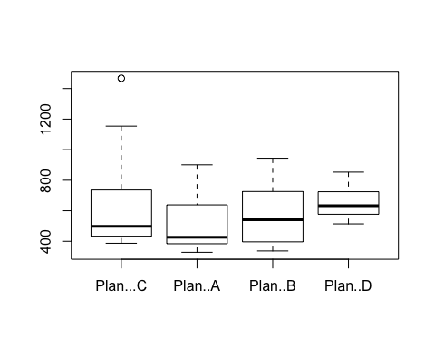

# b. No, as can be seen from output below, the p-value is 0.118  
result<-aov(mdat$values~mdat$ind)  
summary(result)

## Df Sum Sq Mean Sq F value Pr(>F)  
## mdat$ind 3 236991 78997 2.02 0.118  
## Residuals 76 2971587 39100

# c. None of the pairs have a significant difference at alpha = 0.05. However, if we were to consider alpha =0.15, which is reasonable, than the A-D pair would be significantly different.  
  
TukeyHSD(result)

## Tukey multiple comparisons of means  
## 95% family-wise confidence level  
##   
## Fit: aov(formula = mdat$values ~ mdat$ind)  
##   
## $`mdat$ind`  
## diff lwr upr p adj  
## Plan..A-Plan...C -114.25 -278.50321 50.00321 0.2687517  
## Plan..B-Plan...C -71.05 -235.30321 93.20321 0.6684064  
## Plan..D-Plan...C 21.45 -142.80321 185.70321 0.9860117  
## Plan..B-Plan..A 43.20 -121.05321 207.45321 0.9002825  
## Plan..D-Plan..A 135.70 -28.55321 299.95321 0.1409468  
## Plan..D-Plan..B 92.50 -71.75321 256.75321 0.4549244

#14.6  
#a. Yes, normality condition is violated:   
  
r<-residuals(result)  
rs<-rstandard(result)  
  
# check the normality of residuals  
qqnorm(rs, pch=16, cex=.5)  
qqline(rs,col=2)  
shapiro.test(rs)

##   
## Shapiro-Wilk normality test  
##   
## data: rs  
## W = 0.88326, p-value = 2.56e-06

#b.   
library(car)

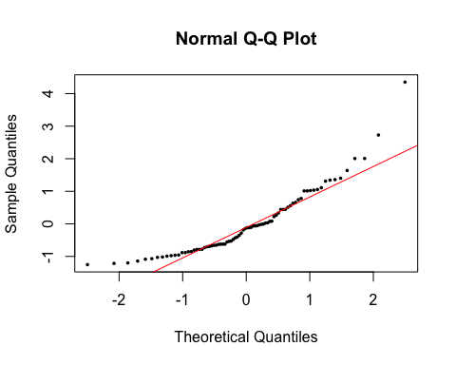

leveneTest(mdat$values~mdat$ind)

## Levene's Test for Homogeneity of Variance (center = median)  
## Df F value Pr(>F)  
## group 3 2.062 0.1123  
## 76

# Not enough significance to support Ha (not same variances) in this case